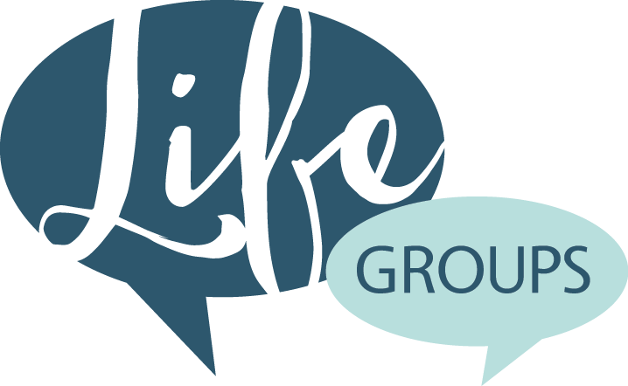
SERMON: Peaceful Revolution
Series: Two Sides to Every Story
Derek Sanford
March 20, 2016

Life Group Discussion Questions:
- What an awesome sermon! Was there a particular point or passage that challenged you, confused you, or caught your attention?
- What were your previous thoughts and feelings regarding Palm Sunday? How does Derek’s history of the Maccabean Revolt shake up your previous perceptions of Jesus riding into Jerusalem on a donkey?
- How are we similar to the crowd that showered Jesus with Hosannas on Palm Sunday and then cried crucify him so soon after?
- Read Luke 19:41-42- With the past as our teacher, we clearly see that the Jews were unable to grasp the meaning of Jesus’ words and mission on earth. They focused upon the overthrow of Rome even as he offered a far greater peace. What do we plead for today (this week), even as we miss the opportunity to receive this greater peace from God?
- Our first Battle Cry: The way to ultimate peace is through surrender to Christ Read: Proverbs 3:6, Job 22:21 and Chronicles 30:8- Like the crowd, we may discover that Jesus is not the king we thought he would be. When we are in an “impossible” season and our prayers seem to go unheard how can we know that peace is not a feeling, but a person?
- Our second Battle Cry: The way to ultimate power is through humility
Read: Proverbs 15:33 and 11:2, James 3:13. Derek said, “Imagine Jesus on a donkey, the most powerful being in the universe on the back of a beast of burden. The triumphal entry reminds us that sometimes moments of great strength are disguised as moments of great weakness. Jesus was clear. The first will be last. Those who want to be great must be a servant of all…”

APPLICATION: List ways that we can resist the tide of our culture that scoffs at humility. Who can you invite to Easter? How are you preparing spiritually to celebrate Holy Week?

Prayer Thought: Lord hear our battle cries, help us to surrender to you, accept your peace, and think and act with humility. Keep us mindful of Jesus’ choice to enter Jerusalem on the back of a donkey.

