Remote User Log In

This applies to remote users, contacts receiving mail sent to aliases such as “techhc”, “recovery”, “missions”, etc.

There is a password policy on the server requiring everyone with a user account to change it every 90 days. If you sit at a computer in the office, you will get the prompts to change it when it gets close to the 90 day mark. If you are a remote user who never comes in to the office, you will run into the issue where your password expires, you are not aware of it and thus start missing email.  You will not get any indication that your password has expired if you only use your phone for email.

My recommendation for all remote users is to use Outlook Web Access whenever possible.  This not only provides a better user experience for managing, viewing and responding to emails, but will also give you the ability to change your password from it.

The URL for Outlook Web Access is <https://mail.whoisgrace.com/owa>

The format to login is

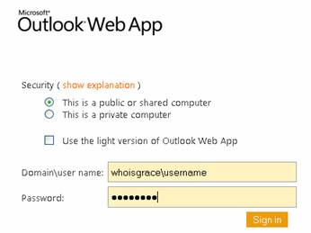

If you have an expired password, you will see the screen below.  Use the same format as above to change your password.

